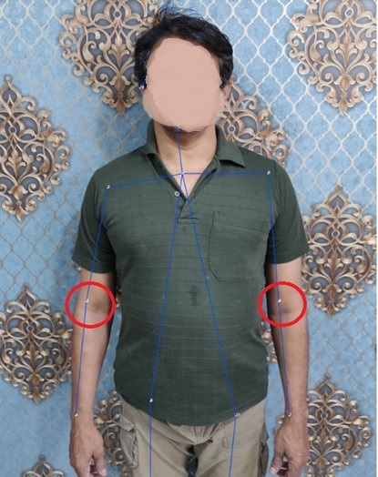

Fig: Co-ordinates of Left and Right Elbow encircled Red

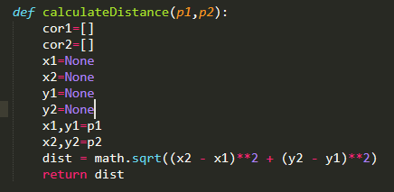

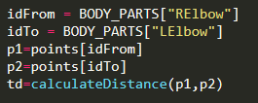

**Algorithm for Size Prediction:-**

1.Using the Pose Estimation we extract the pixel co-ordinates of Left and Right Elbow of the User

2.The extracted co-ordinates of Left and Right Elbow are then passed to “calculateDistance()” function to find the distance between two points.

3.Based on this calculated distance the T-shirt size is assigned a category out of Small, Medium and Large sizes.

4.These T-shirt sizes are also used in Superimposition of T-shirt on the user.

**Limitation for Size Prediction:-**

1.The device used to capture the image of the user should remain same for taking every further image.

2.The distance between the device(camera) and the user should be fixed.

3.Need of proper Lightning.